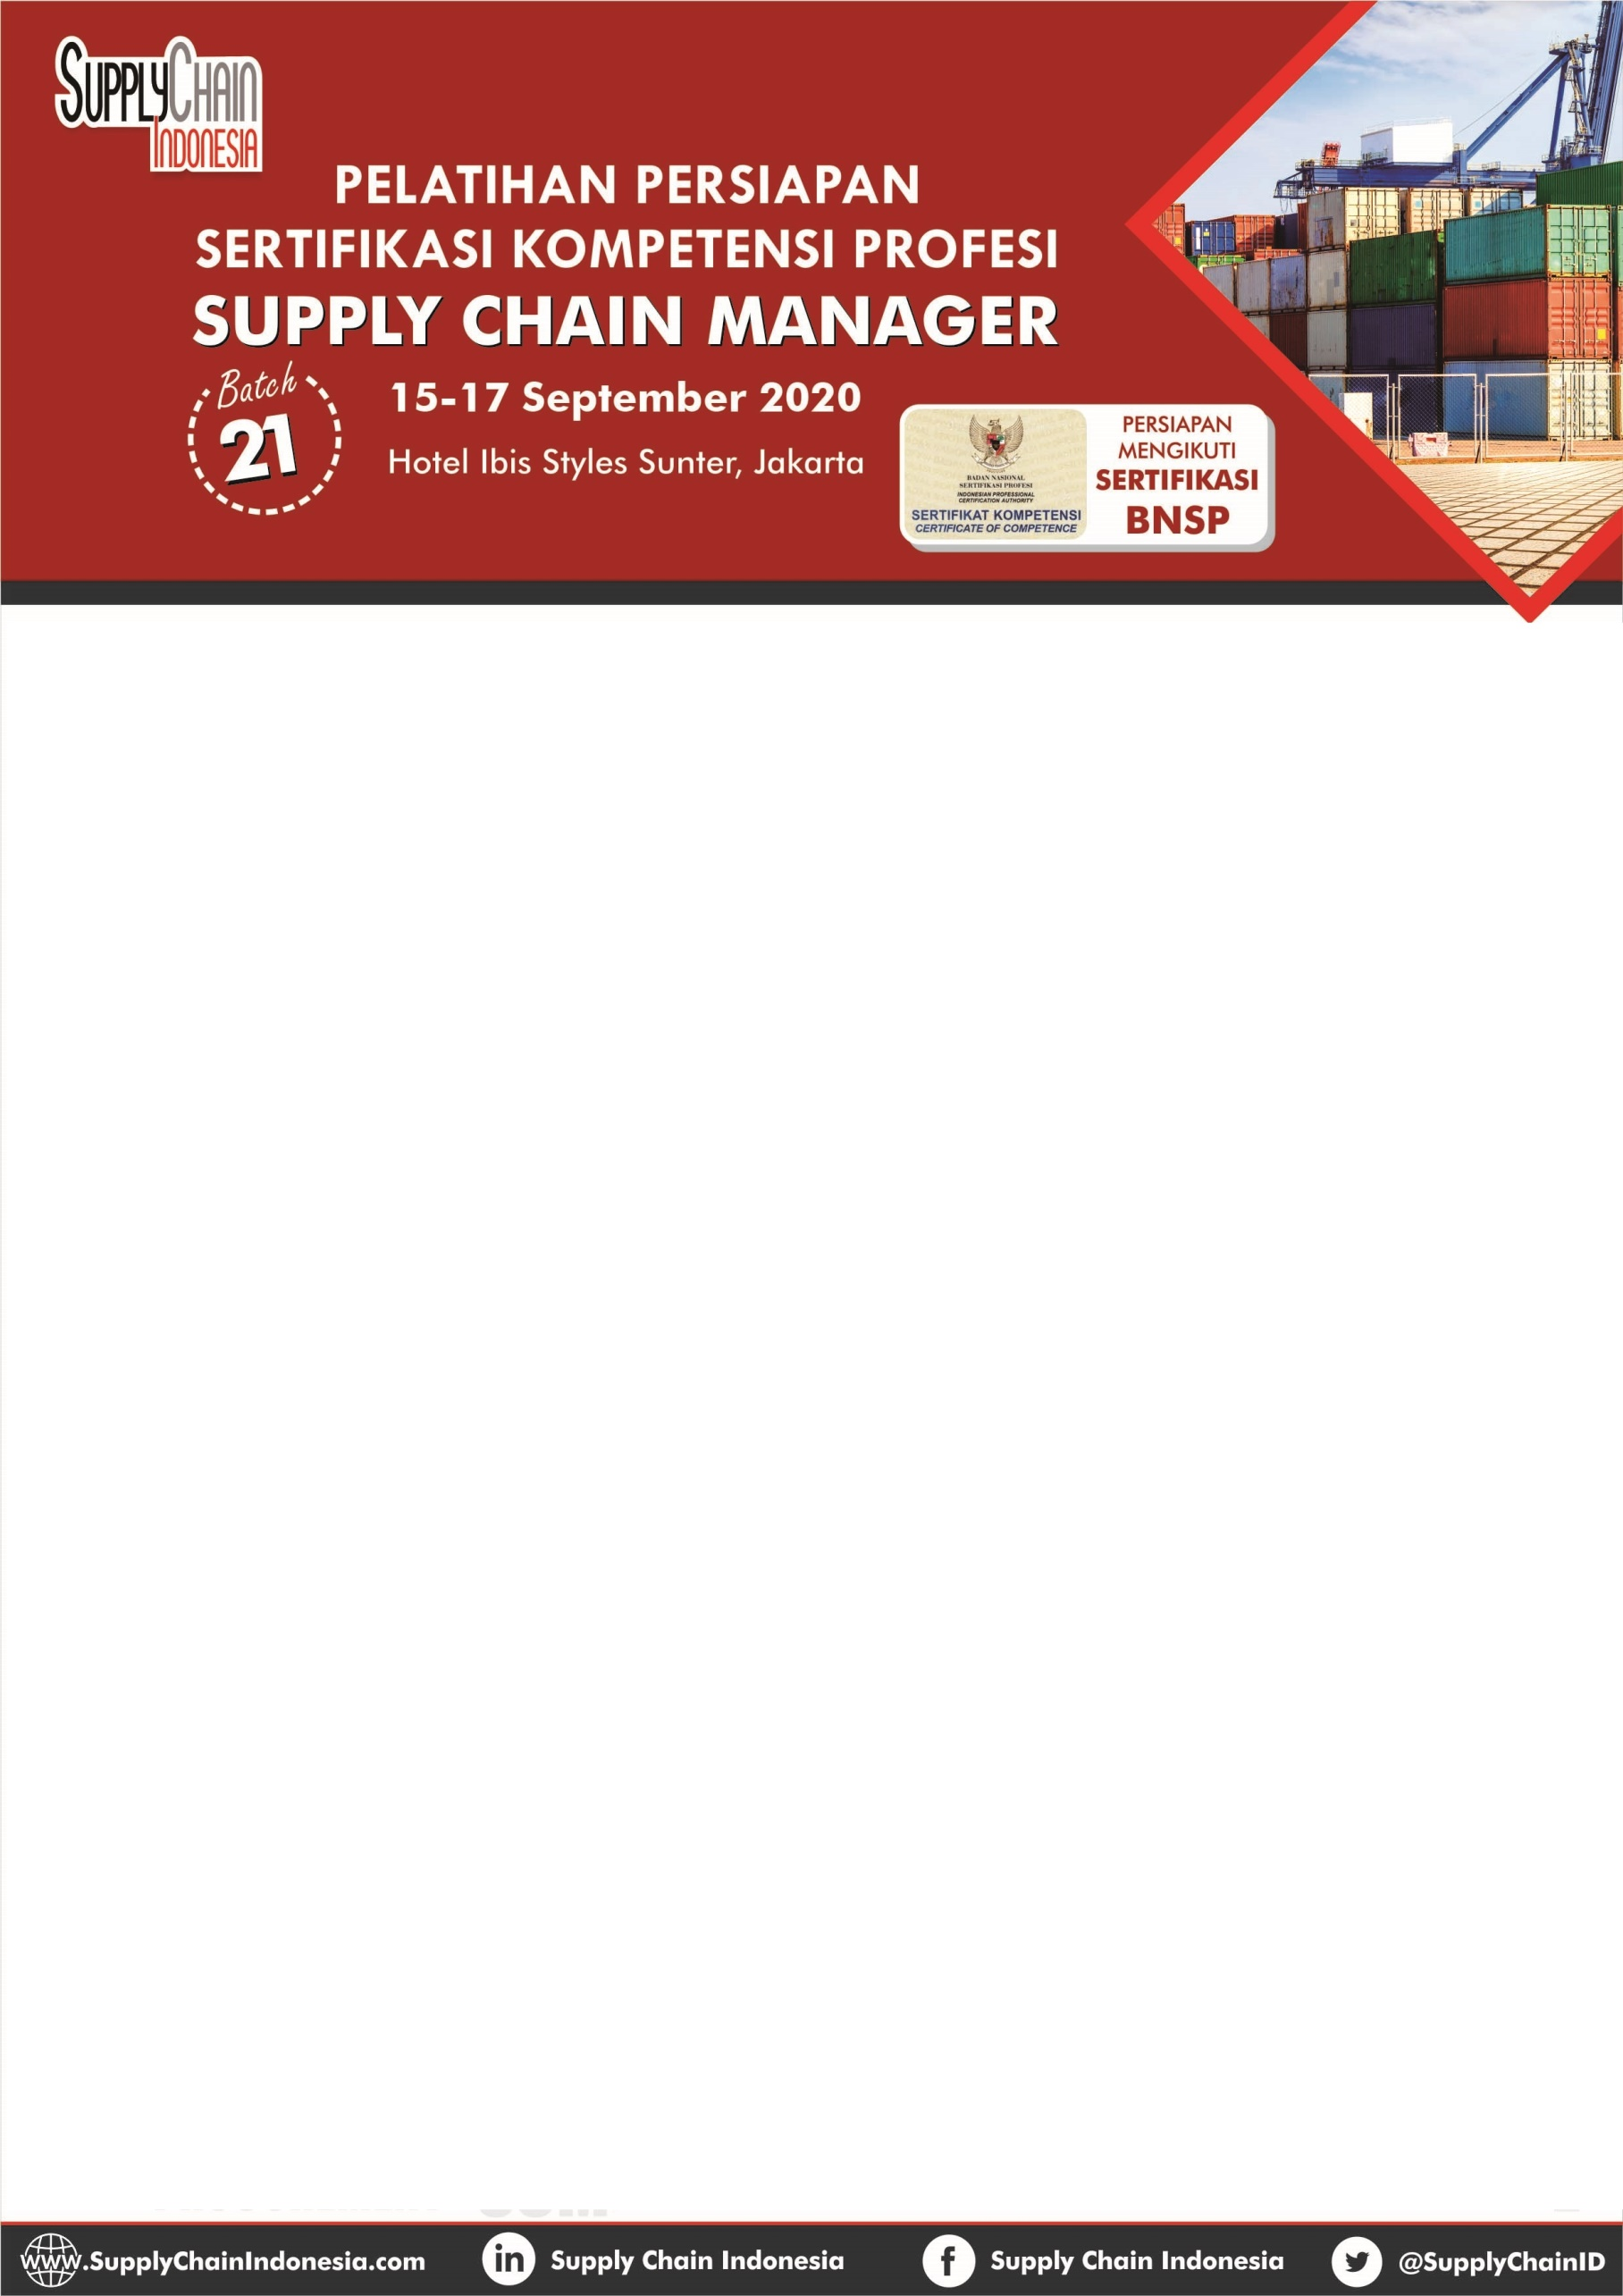

D A T A P ERUSAHAAN

Nama Perusahaan/Instansi : …………………………………………………………………………………………………
Alamat Perusahaan/Instansi : …………………………………………………………………………………………………
…………………………………………………………… Kode Pos : ……………………
No. Telp. : …………………………………………………………………………………………………

P ESERT A 1

Nama : …………………………………………………………………………………………………
Jabatan/Departemen : …………………………………………………………………………………………………
No. HP : …………………………………………………………………………………………………

Alamat Email
: …………………………………………………………………………………………………

P ESERT A 2

Nama : …………………………………………………………………………………………………
Jabatan/Departemen : …………………………………………………………………………………………………
No. HP : …………………………………………………………………………………………………

Alamat Email
: …………………………………………………………………………………………………

P ESERT A 3

Nama : …………………………………………………………………………………………………
Jabatan/Departemen : …………………………………………………………………………………………………
No. HP : …………………………………………………………………………………………………
Alamat Email : …………………………………………………………………………………………………

Formulir Registrasi dan Bukti Pembayaran dikirimkan selambatnya 4 September 2020 ke:
sekretartiat@SupplyChainIndonesia.com

i

